**DEVOPS LABORATORY**

**Name:** Dhilip Kumar M **Date:** 29.05.2024

**Roll Number:** 7176 21 05 015 **Experiment No.:** 06

**WORKING WITH ANSIBLE**

**Aim:**

To create and execute ansible playbooks, to configure inventory file and execute in different methods and to create ansible roles for starting service.

**Installing Ansible on Ubuntu:**

* sudo apt-add-repository ppa:ansible/ansible
* sudo apt update
* sudo apt install ansible

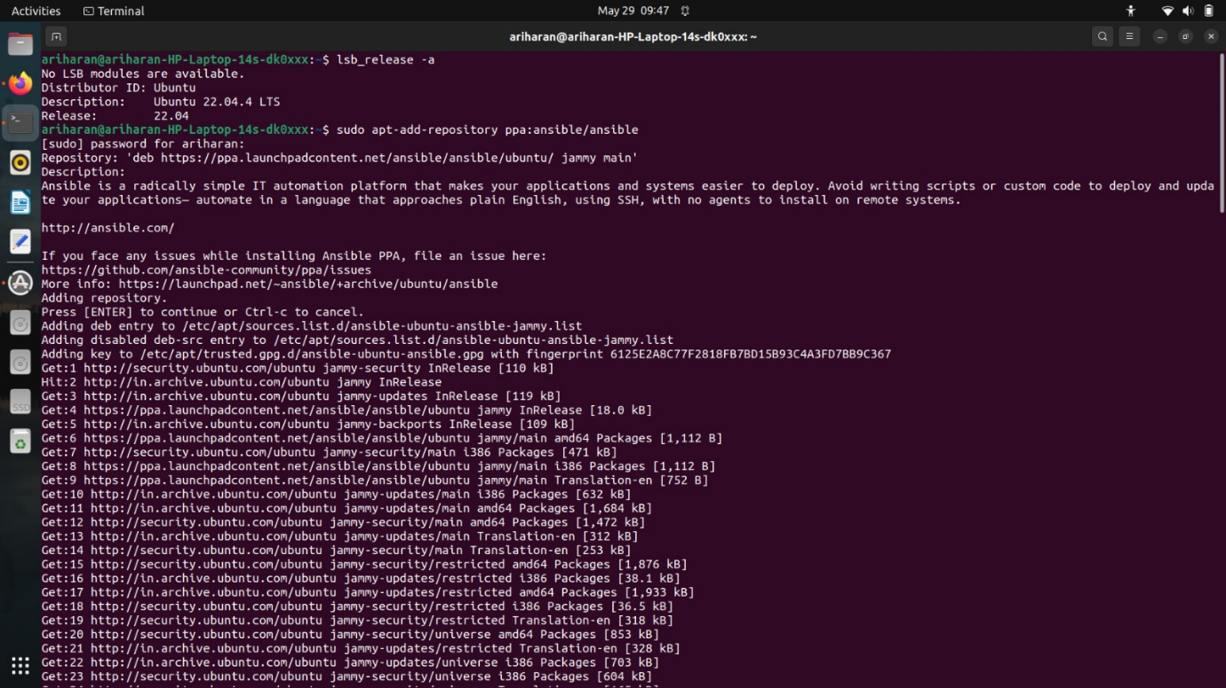

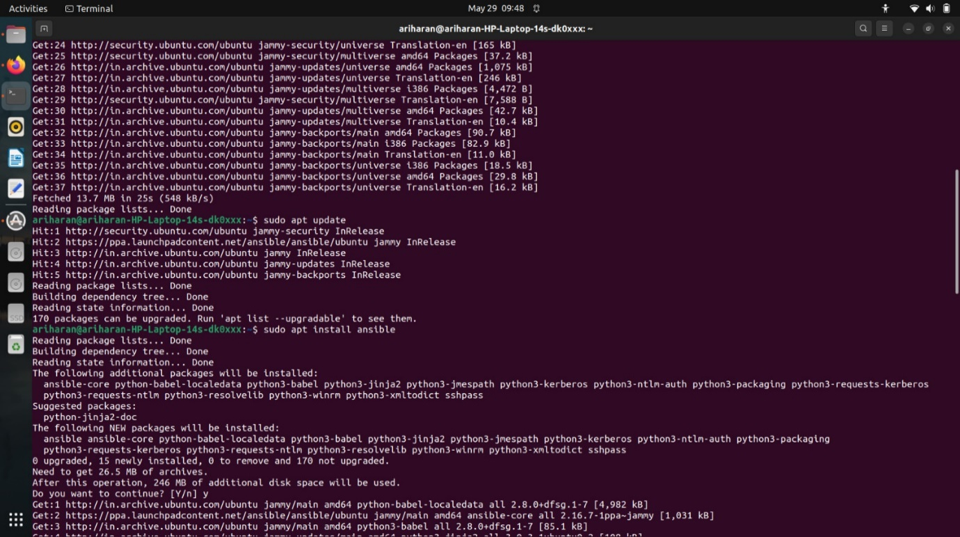

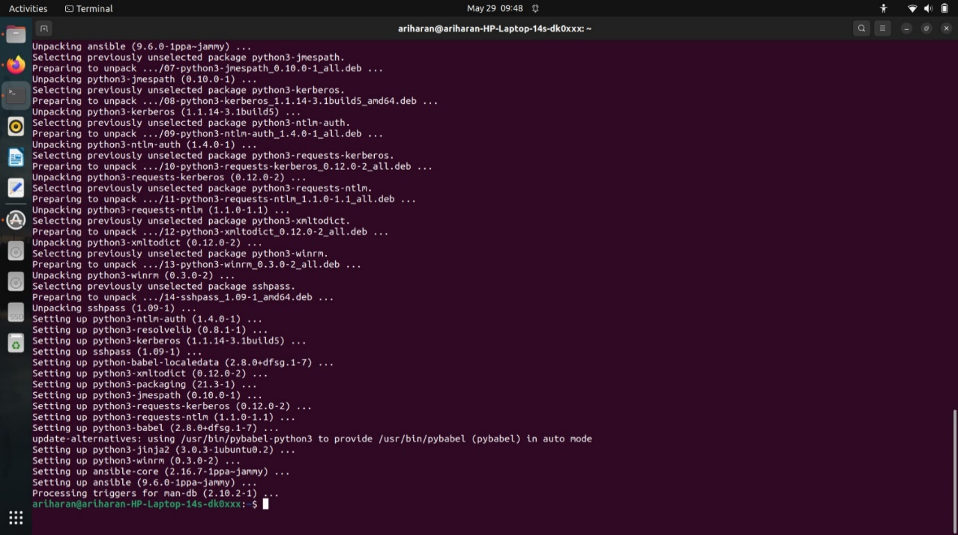

**Configuring the system with ‘UTF-8’ to support Ansible:**

* sudo locale-gen en_us.utf-8
* export lang=en_us.utf-8
* export lc_type=en_us.utf-8
* sudo update-local lang-en_us.utf-8 lc_ctype=en_us.utf-8

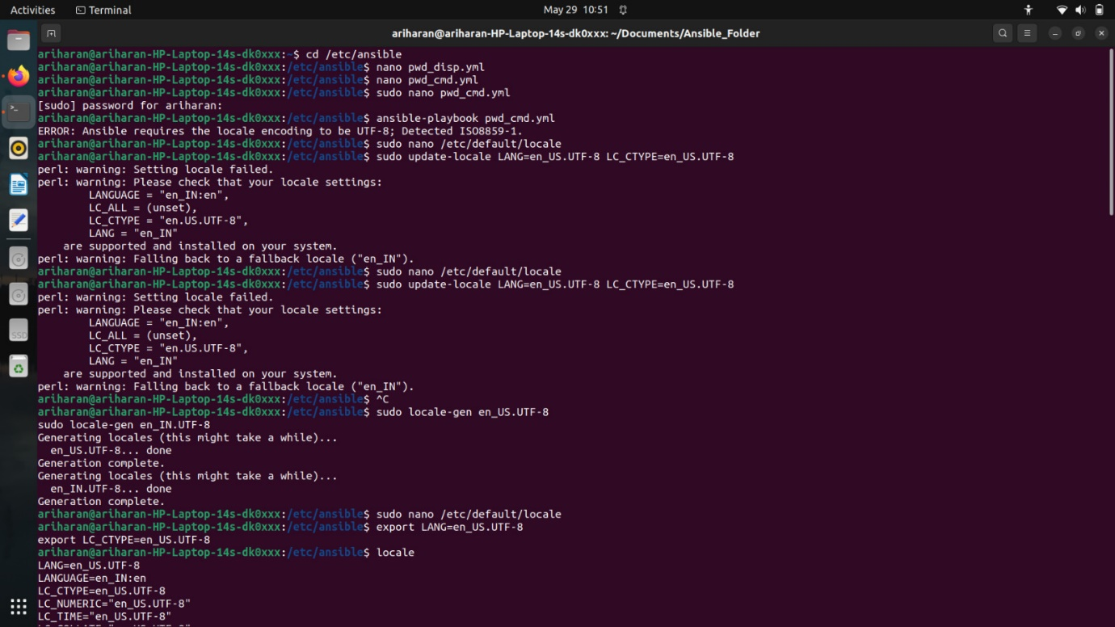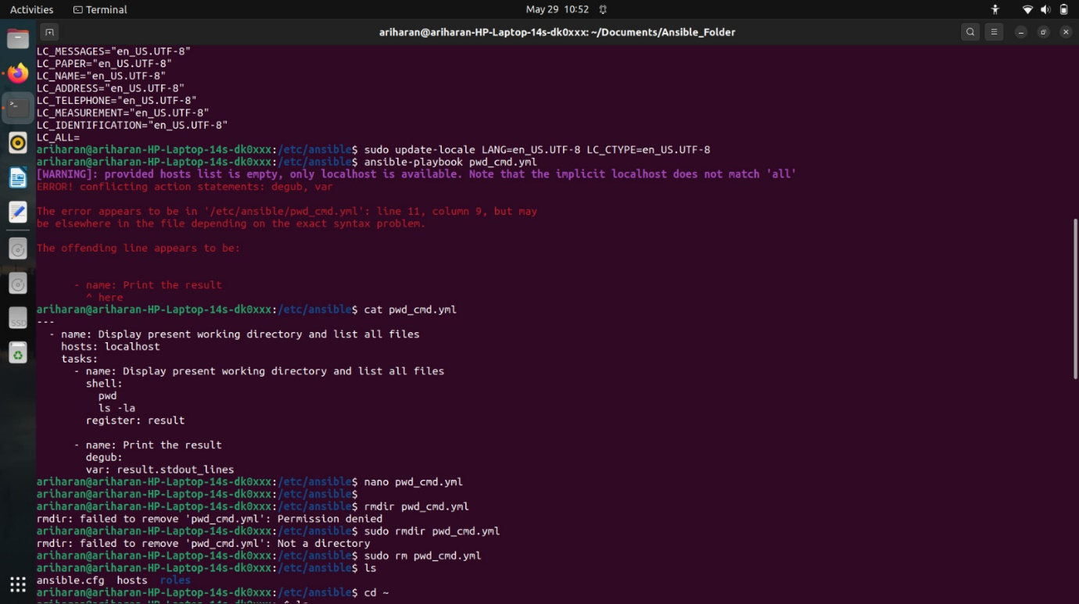

**-----------------------------------------------Exercise 1-----------------------------------------------**

**Create Ansible playbooks to execute the shell commands for the following tasks.**

**(a) Display the present working directory and list all files in pwd.**

1. Open a file as *pwd_ls_cmd.yml*
2. Paste the following content into the file and save it.

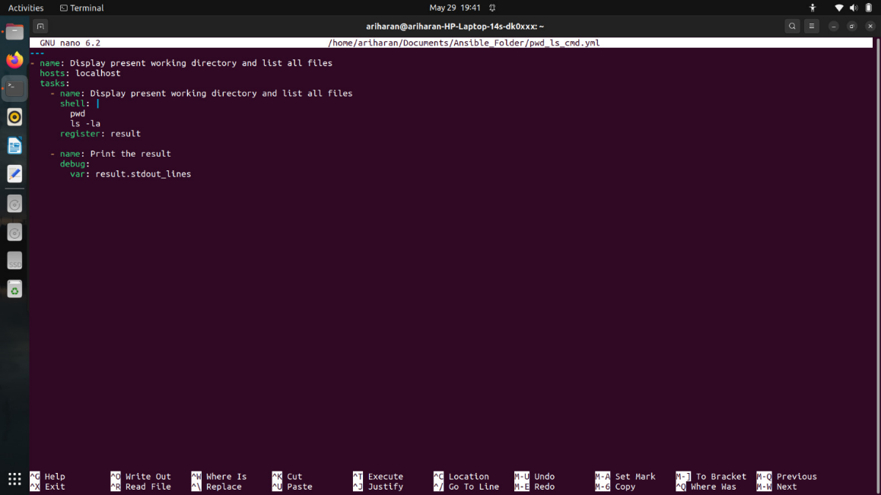

1. Run *ansible-playbook pwd_ls_cmd.yml* to get the output.

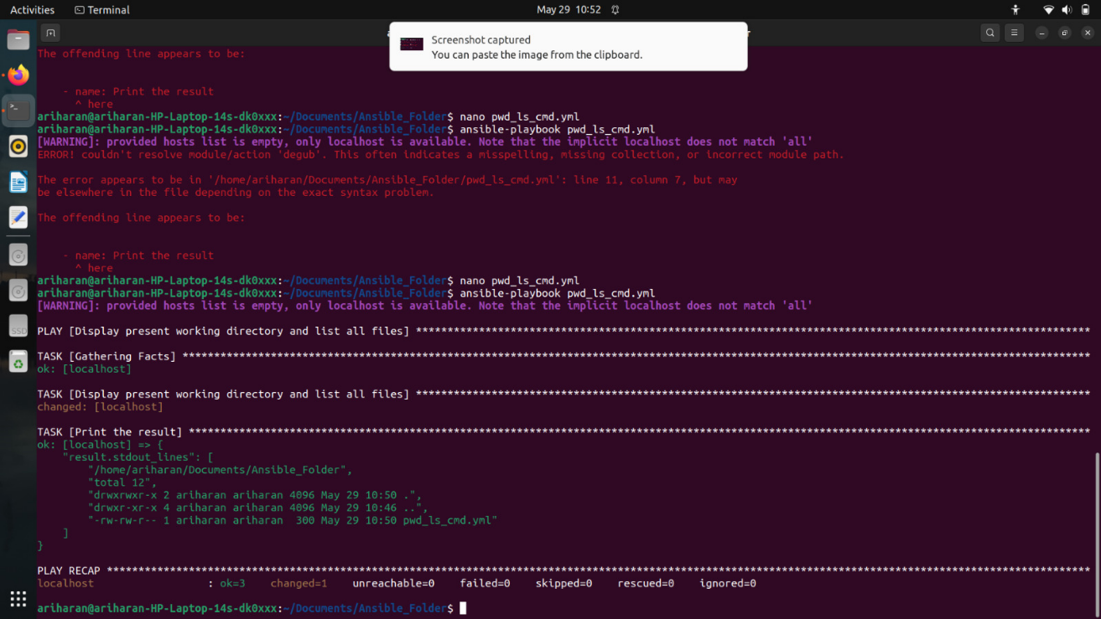

**(b) Open a file using cat command.**

1. Open a file as *cat_print_cmd.yml*
2. Paste the following content into the file and save it.

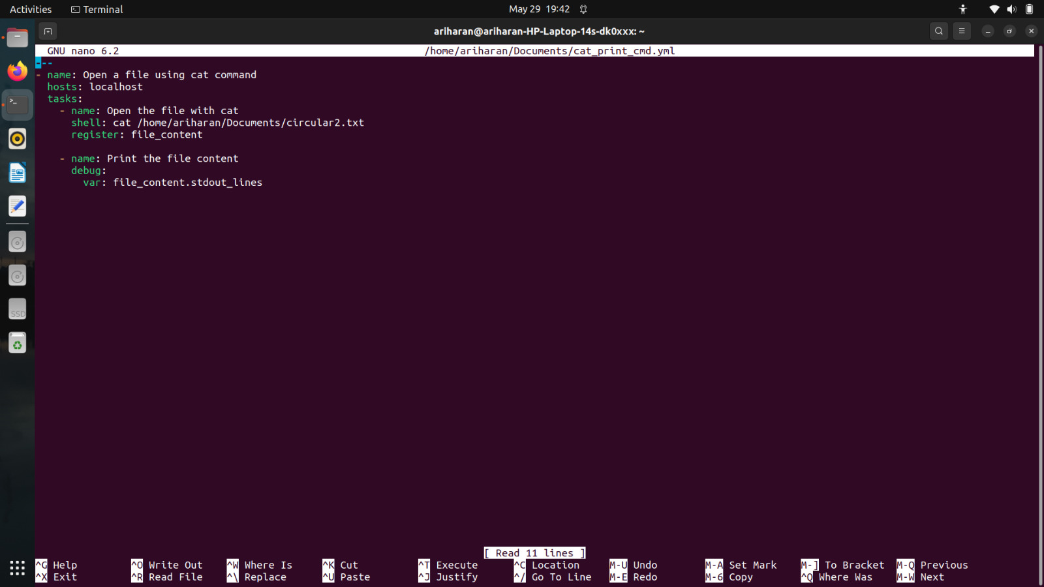

1. Run *ansible-playbook cat_print_cmd.yml* to get the output.

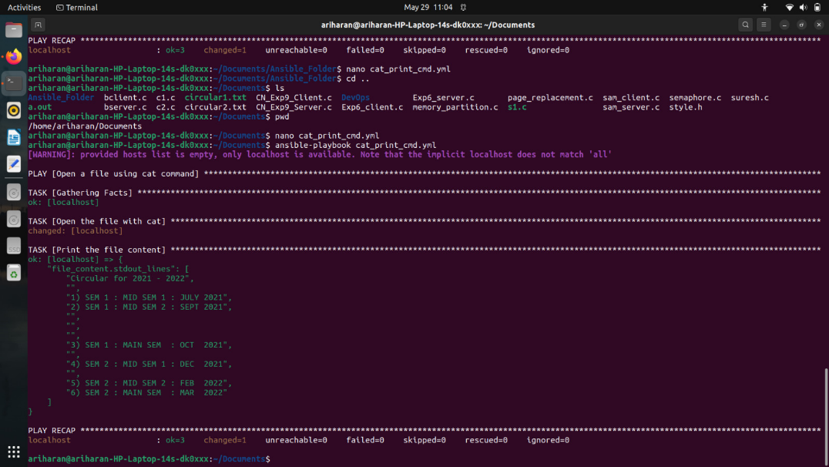

**(c) Create a directory , go to that directory and create a new file.**

1. Open a file as *creat_dir_cmd.yml*
2. Paste the following content into the file and save it.

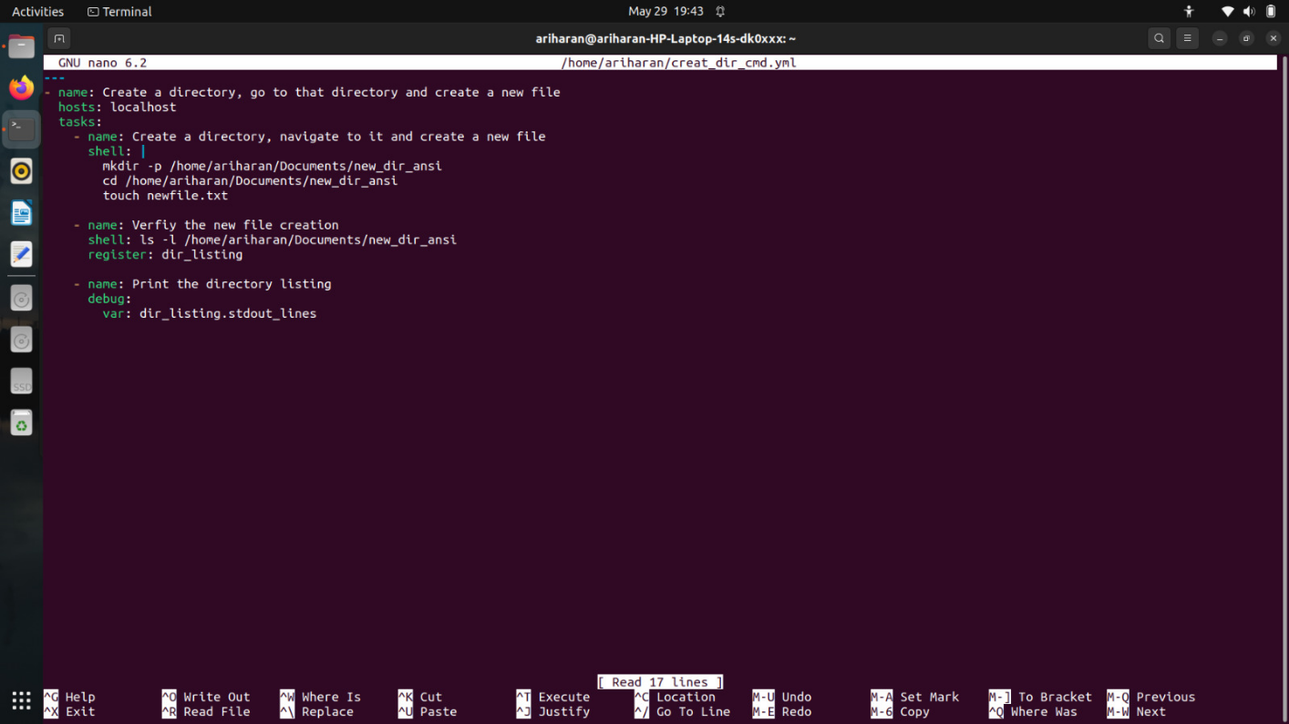

1. Run *ansible-playbook creat_dir_cmd.yml* to get the output.

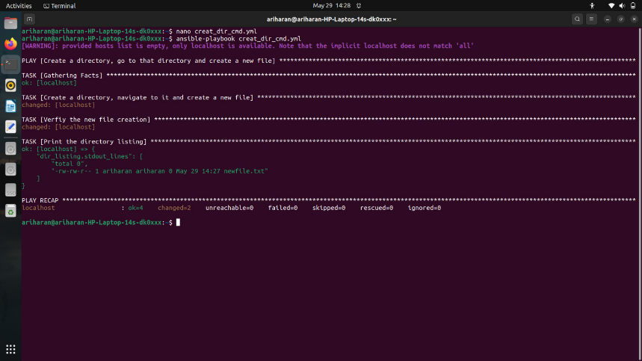

**(d) Copy an existing file into that created directory.**

1. Open a file as copy_paste_cmd*.yml*
2. Paste the following content into the file and save it.

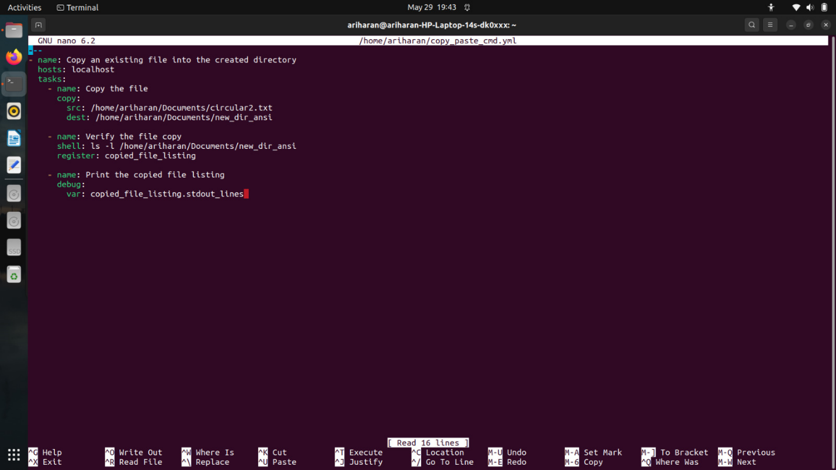

3. Run *ansible-playbook copy_paste_cmd.yml* to get the output.

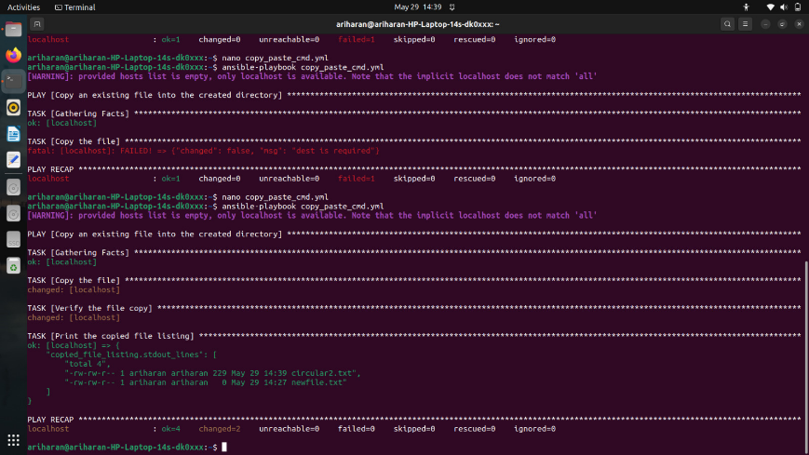

**-----------------------------------------------Exercise 2-----------------------------------------------**

**Create a new inventory file and run ansible playbooks using the server information from the newly created inventory file. Execute both methods.**

1. Create a new file called *my_inventory.ini*
2. Paste the following contents.

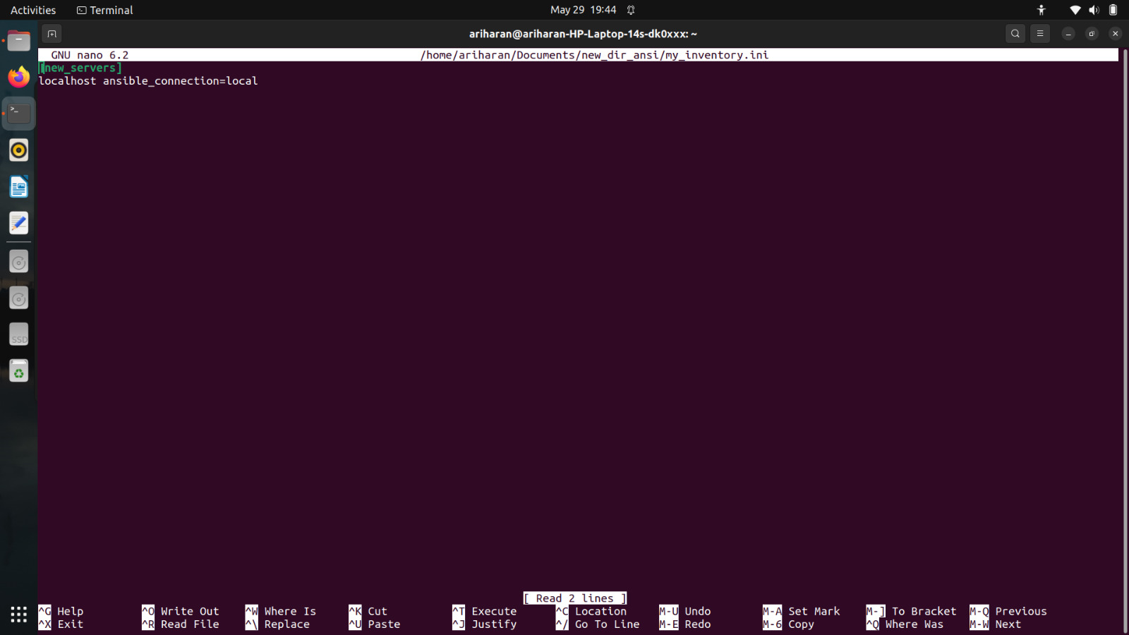

1. Save the file.
2. Create a new file called test_playbook*.yml*
3. Paste the following contents.

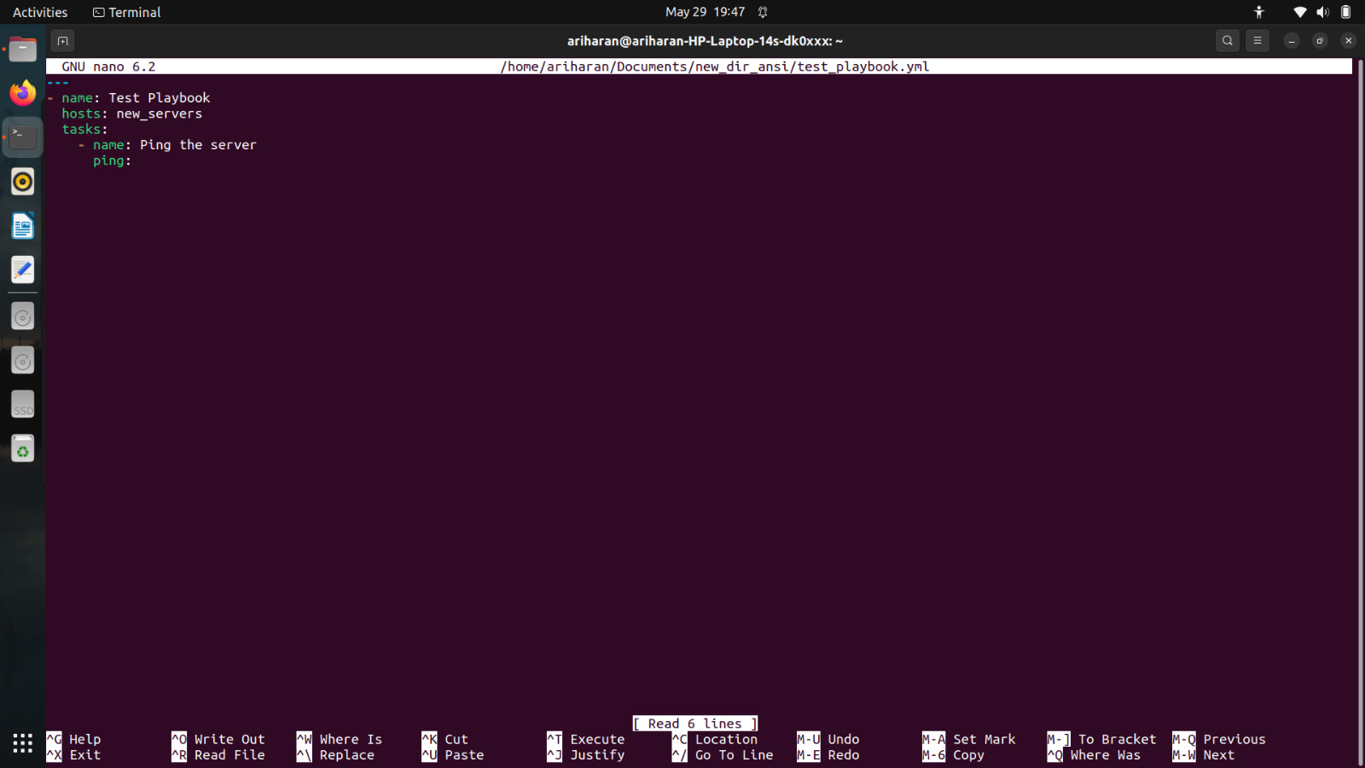

**Method 1:** Change the configuration file

1. Goto /etc/ansible
2. Open ansible.cfg in a text editor and paste the following content

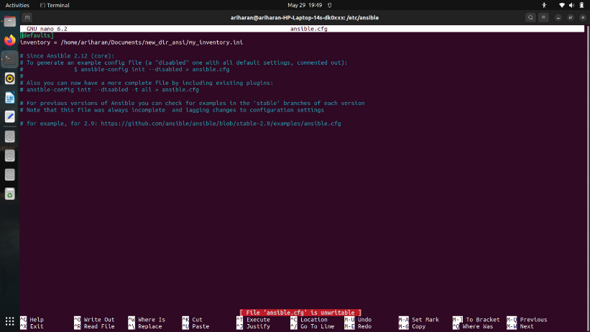

1. Save the file and run test_playbook.yml

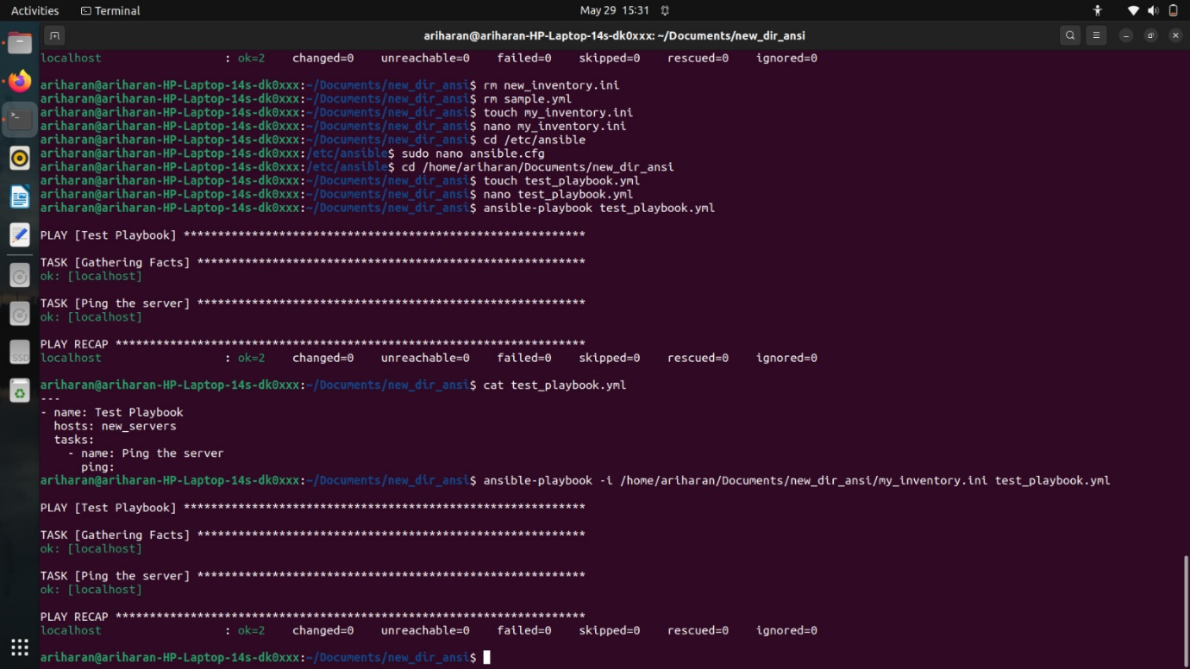

**Method 2**: Pass the inventory file from command prompt

1. Type *ansible-playbook my_inventory.ini* test_playbook*.yml*.
2. The output of ping is as follows

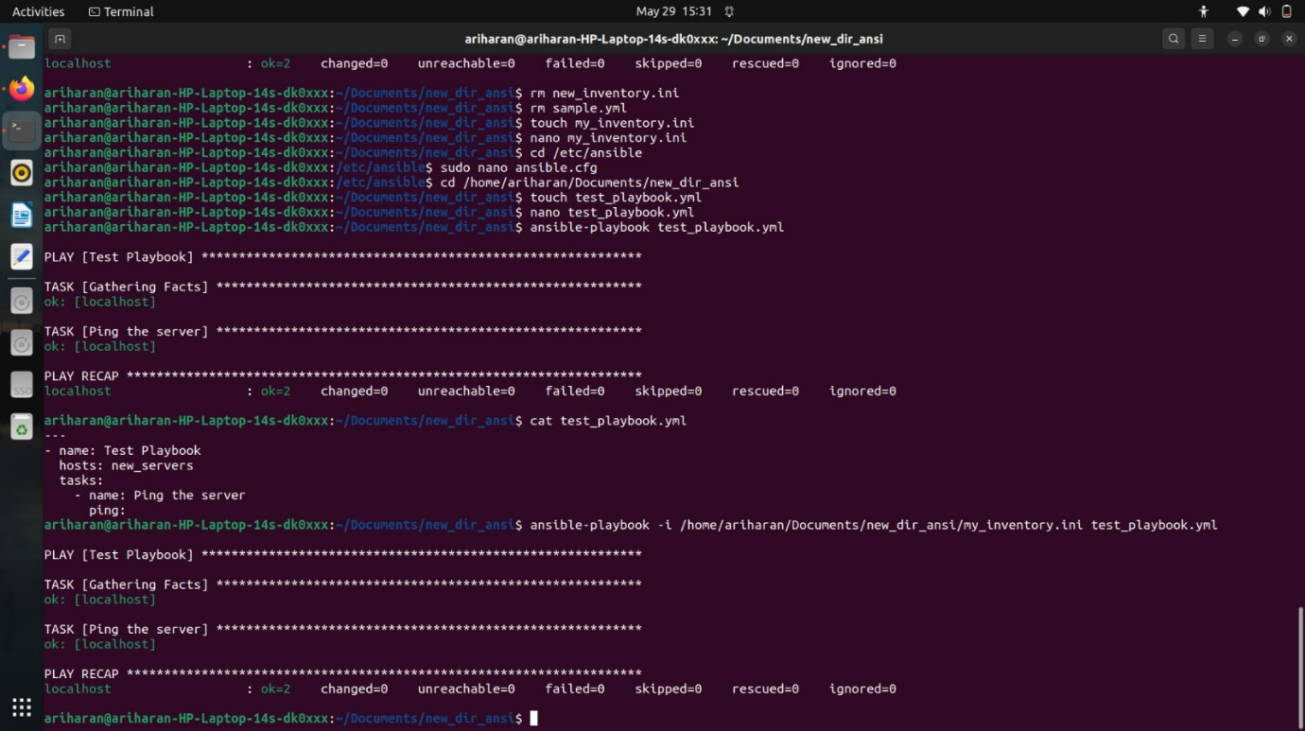

**-----------------------------------------------Exercise 3-----------------------------------------------**

**Create ansible playbooks for installing packages.**

1. Open a file as install_packages*.yml*
2. Paste the following contents.

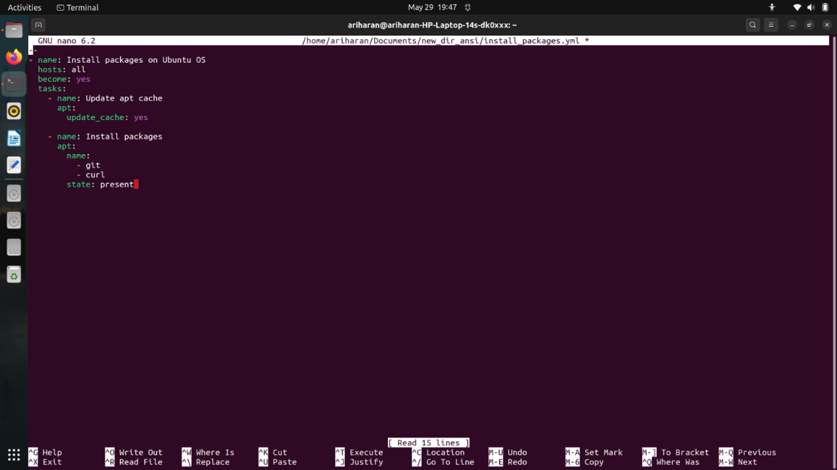

1. Run *ansible-playbook install_packages.yml*. The result is as follows:

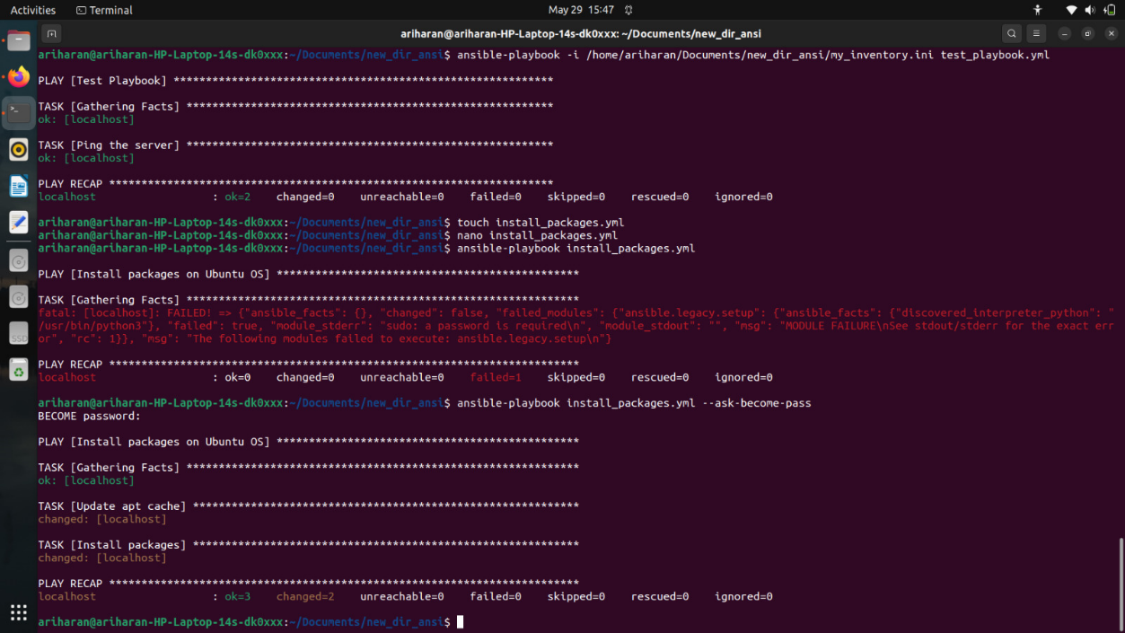

**-----------------------------------------------Exercise 4-----------------------------------------------**

**Create Ansible roles for starting a service.**

1. Navigate to /etc/ansible/roles/
2. Create a folder named my_role
3. Navigate to my_role and within that create a new folders called “tasks, handlers, meta”.

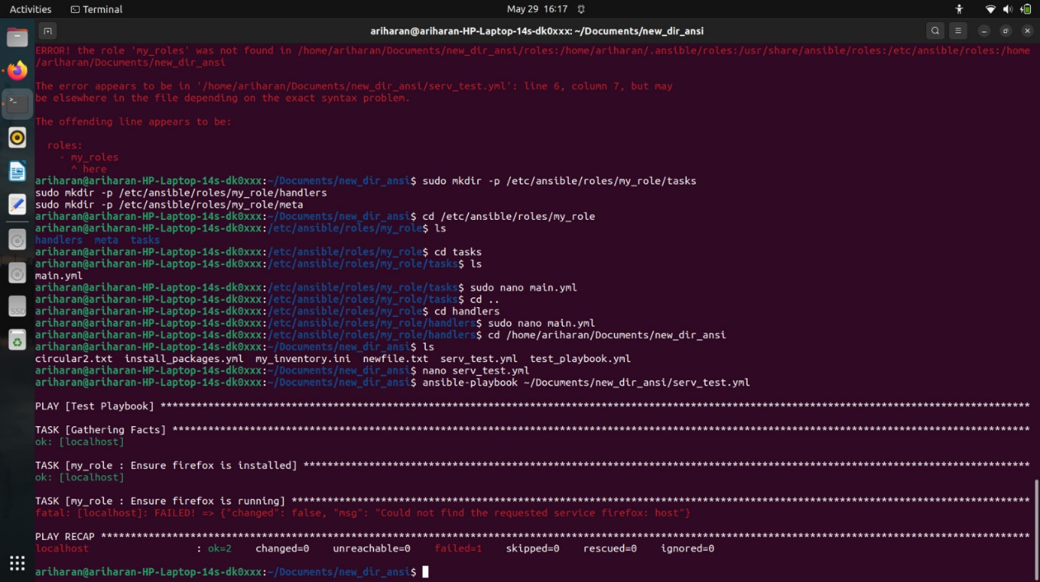

1. Create a new file main.yml within the ‘tasks’ folder and paste the following:

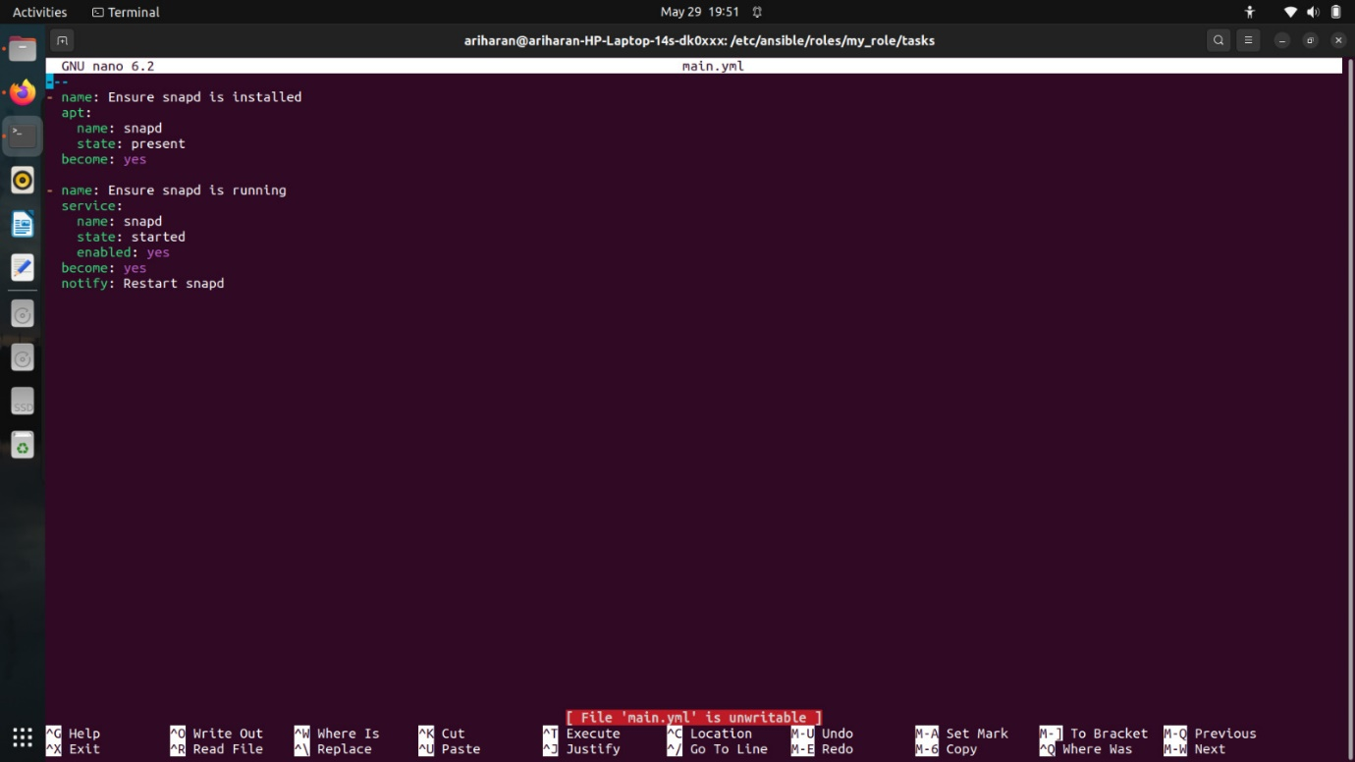

1. Create a new file main.yml within the ‘handlers’ folder and paste the following:

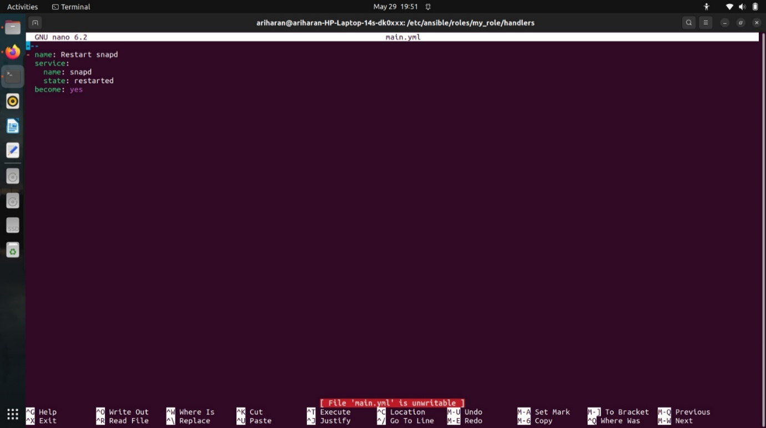

1. In a different folder, create a new playbook to invoke the role. The content is as follows:

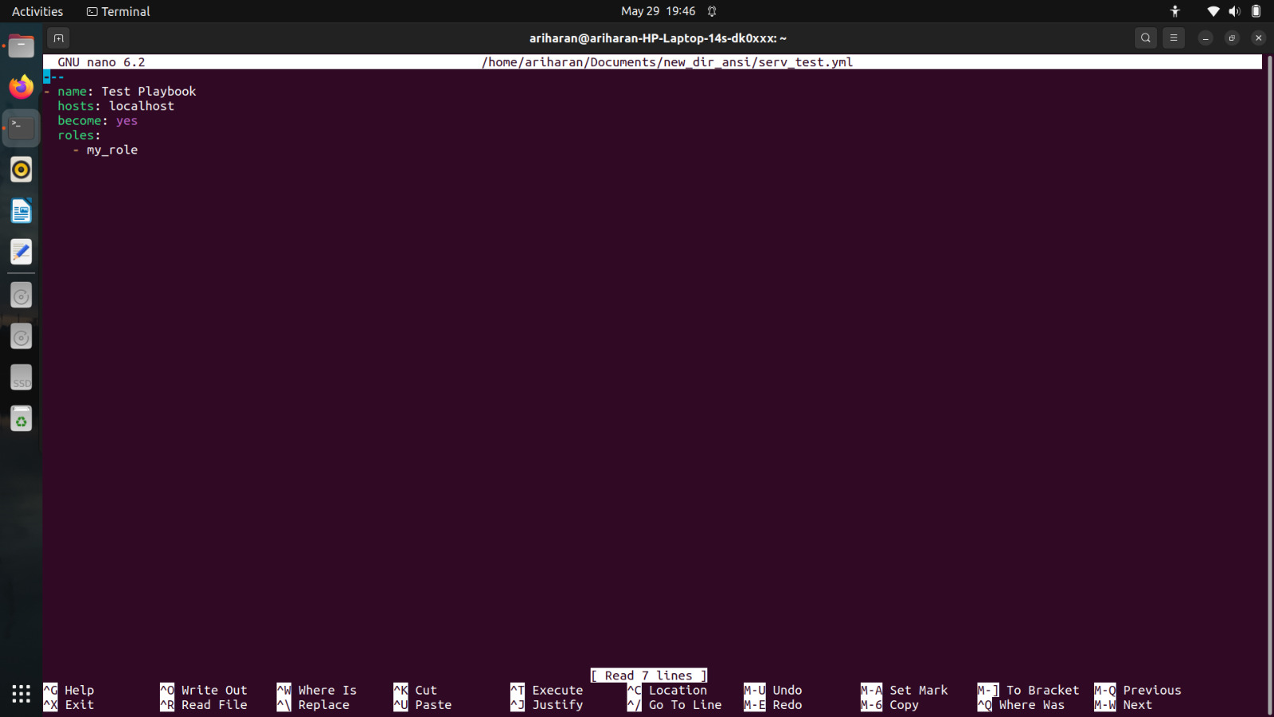

1. Run the playbook.

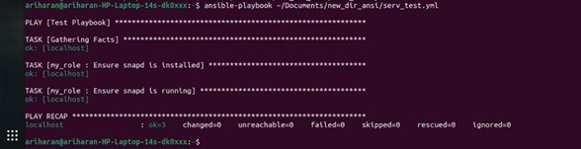

1. Run systemctl status snapd. If a green mark appears, then we can ensure that our role has executed successfully.

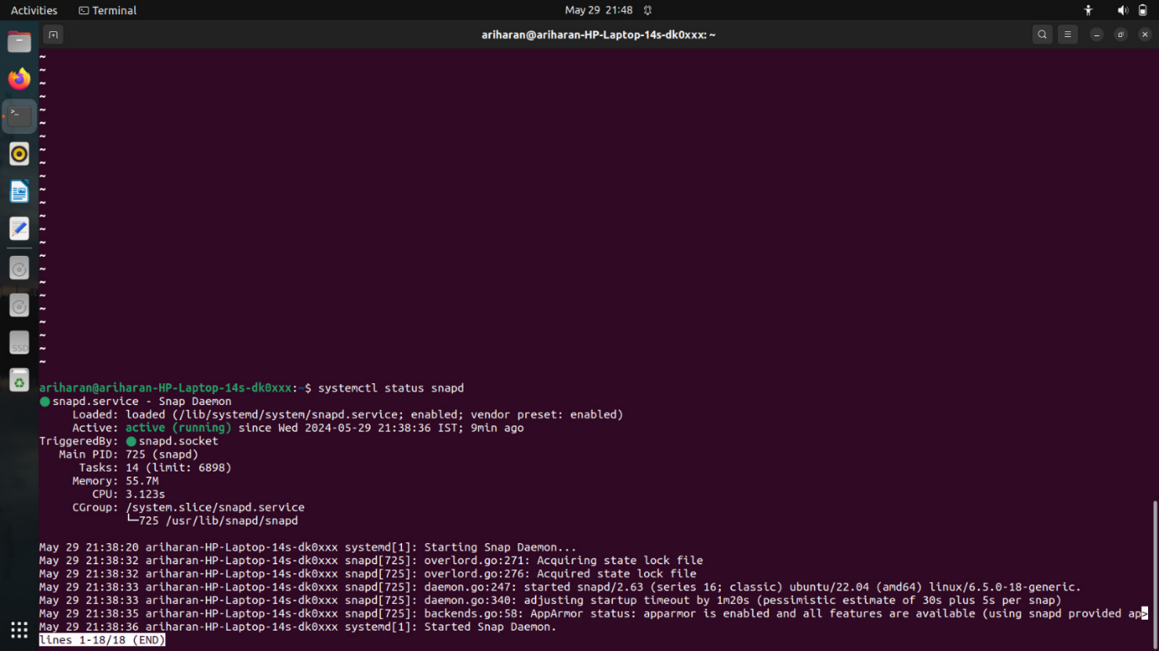

**Result**:

The above code with performs the operations of Ansible has been executed successfully.